**容器生命周期管理**

[run](https://www.runoob.com/docker/docker-run-command.html)





大约在0.6版，privileged被引入docker。

使用该参数，container内的root拥有真正的root权限。

否则，container内的root只是外部的一个普通用户权限。

privileged启动的容器，可以看到很多host上的设备，并且可以执行mount。

甚至允许你在docker容器中启动docker容器。









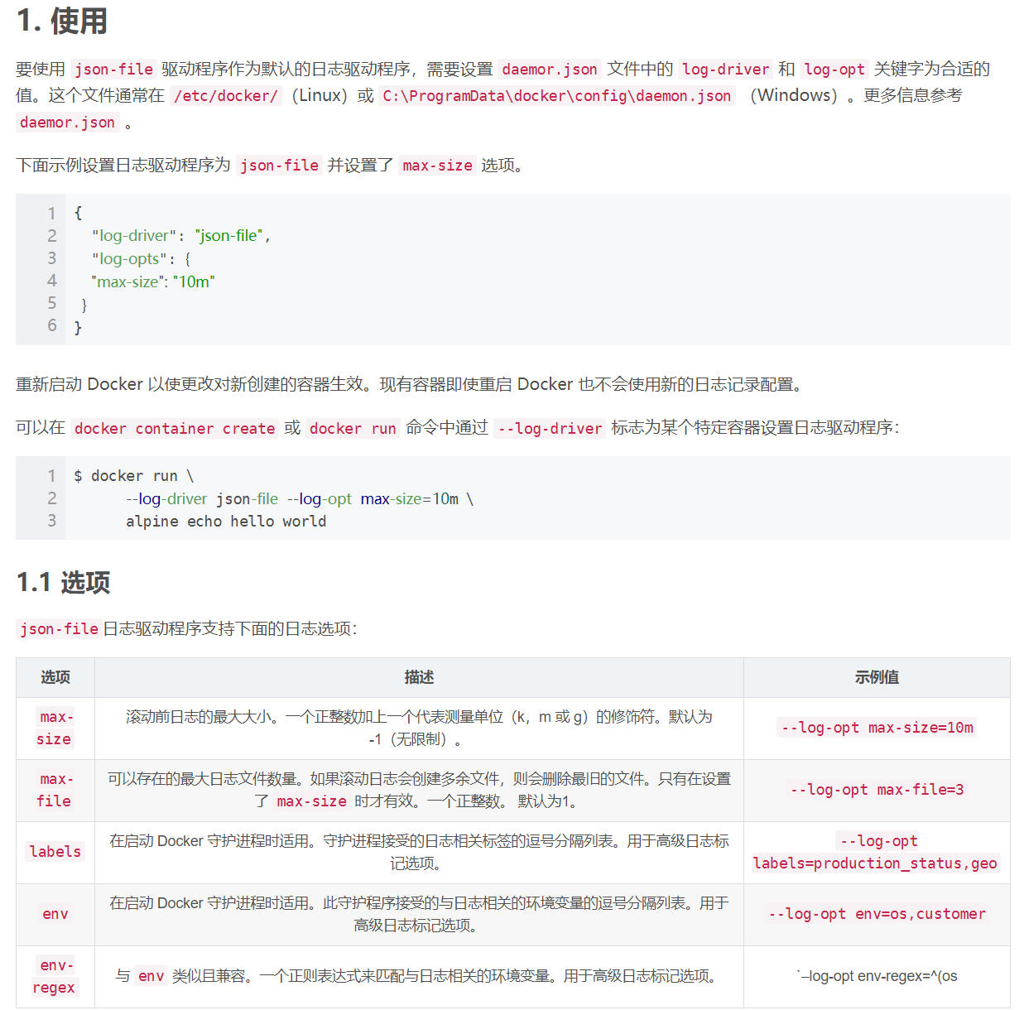







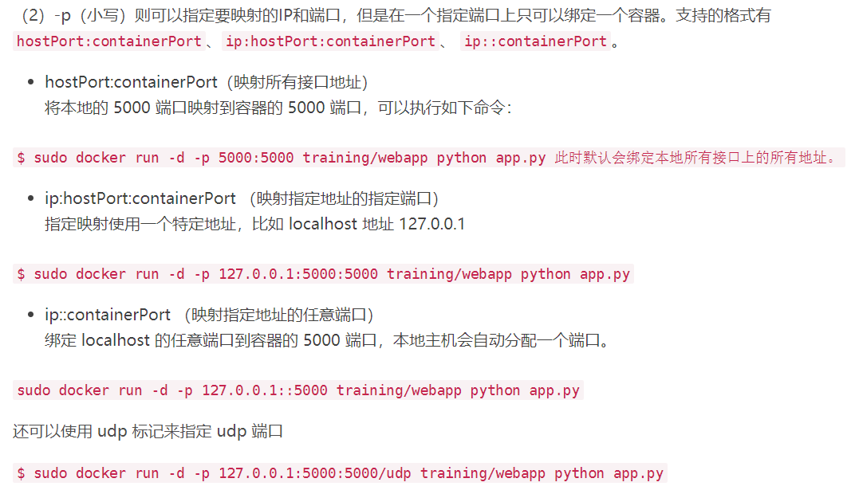

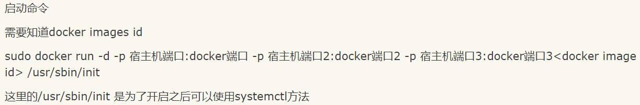

[start/stop/restart](https://www.runoob.com/docker/docker-start-stop-restart-command.html)

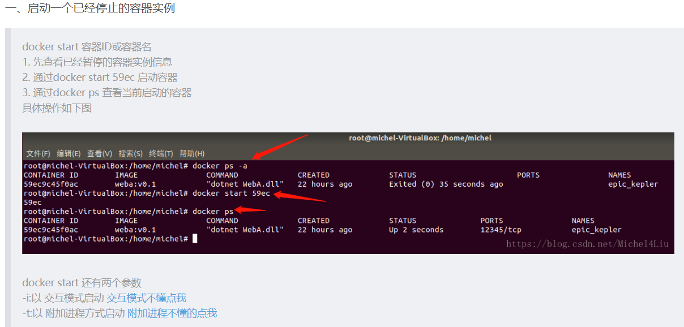

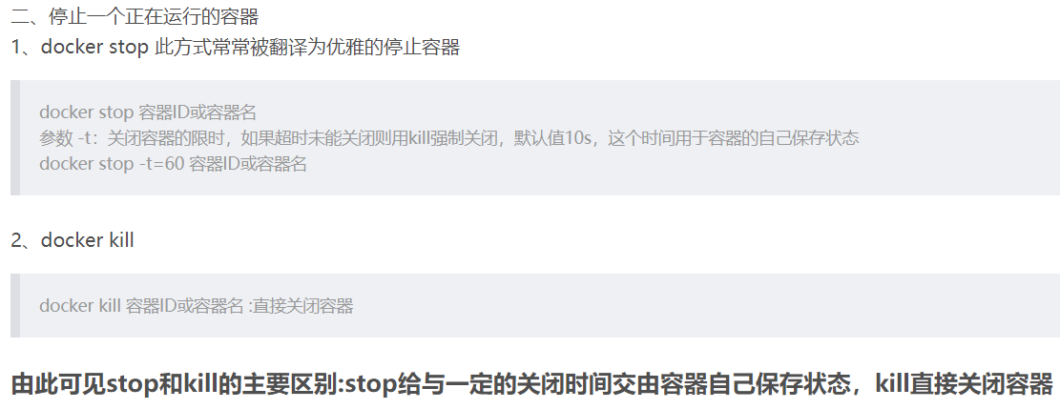

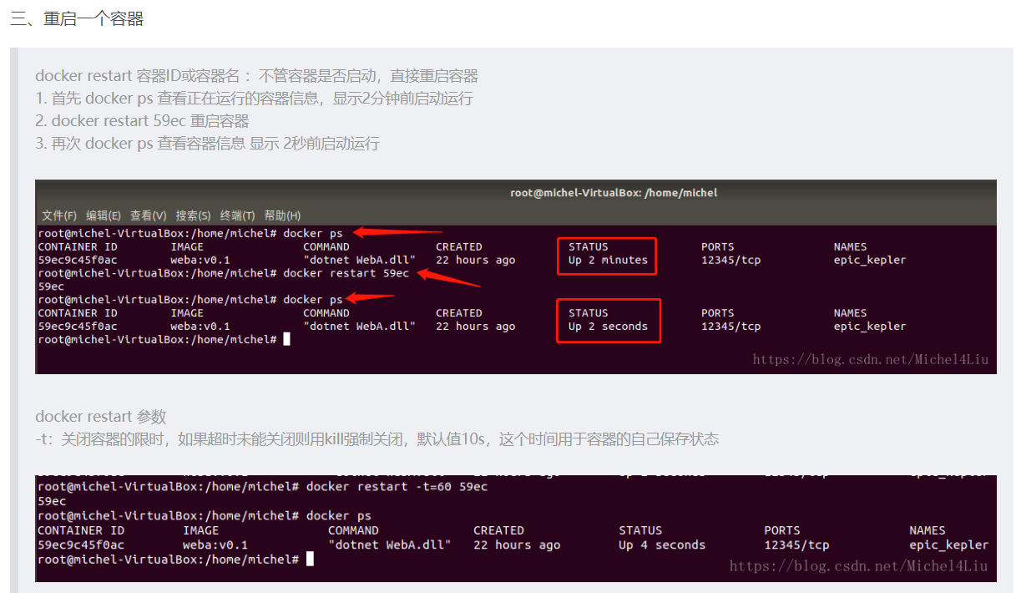

[kill](https://www.runoob.com/docker/docker-kill-command.html)

[rm](https://www.runoob.com/docker/docker-rm-command.html)

[pause/unpause](https://www.runoob.com/docker/docker-pause-unpause-command.html)

[create](https://www.runoob.com/docker/docker-create-command.html)

[exec](https://www.runoob.com/docker/docker-exec-command.html)

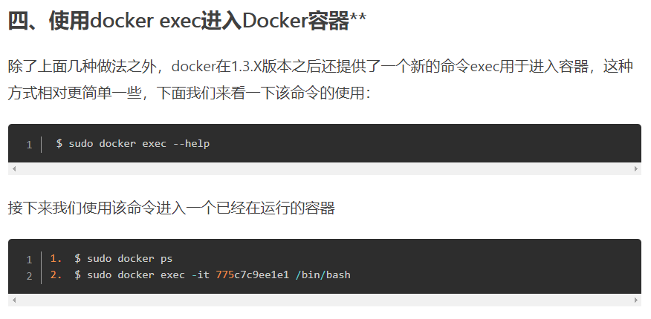

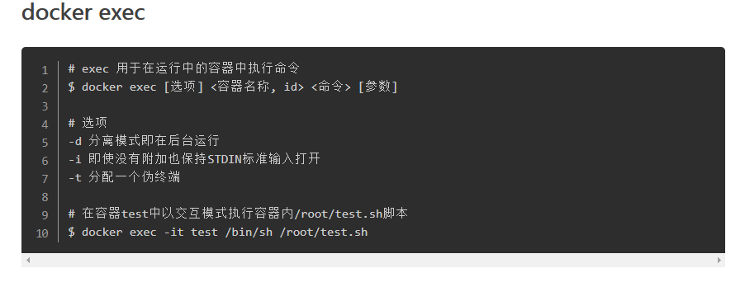

**容器操作**

[ps](https://www.runoob.com/docker/docker-ps-command.html)

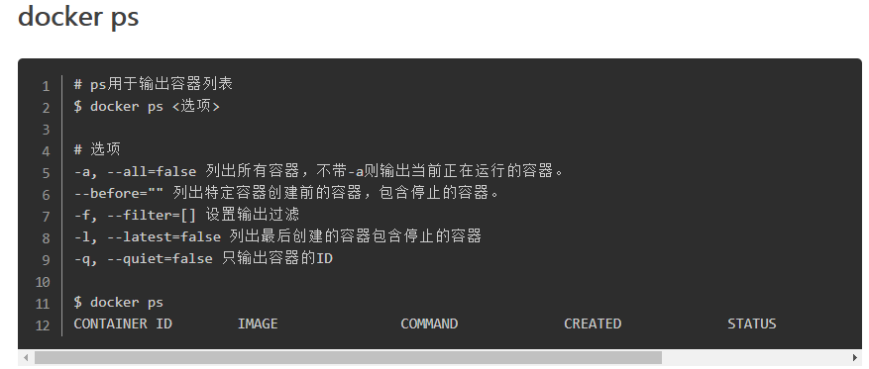

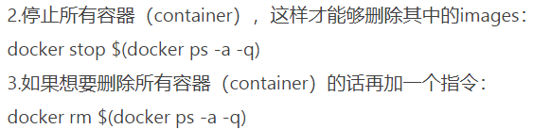

[inspect](https://www.runoob.com/docker/docker-inspect-command.html)

[top](https://www.runoob.com/docker/docker-top-command.html)

[attach](https://www.runoob.com/docker/docker-attach-command.html)

[events](https://www.runoob.com/docker/docker-events-command.html)

[logs](https://www.runoob.com/docker/docker-logs-command.html)

[wait](https://www.runoob.com/docker/docker-wait-command.html)

[export](https://www.runoob.com/docker/docker-export-command.html)

[port](https://www.runoob.com/docker/docker-port-command.html)

**容器rootfs命令**

[commit](https://www.runoob.com/docker/docker-commit-command.html)

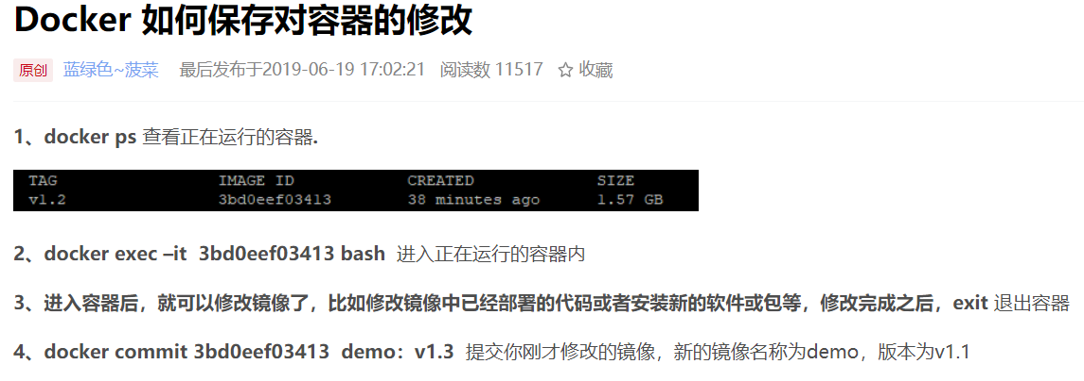

[cp](https://www.runoob.com/docker/docker-cp-command.html)

[diff](https://www.runoob.com/docker/docker-diff-command.html)

**镜像仓库**

[login](https://www.runoob.com/docker/docker-login-command.html)

[pull](https://www.runoob.com/docker/docker-pull-command.html)

[push](https://www.runoob.com/docker/docker-push-command.html)

[search](https://www.runoob.com/docker/docker-search-command.html)

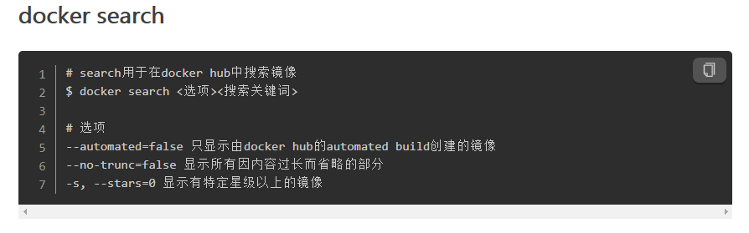

**本地镜像管理**

docker [images](https://www.runoob.com/docker/docker-images-command.html)

docker images ls

这两个都一样

list images

[rmi](https://www.runoob.com/docker/docker-rmi-command.html)

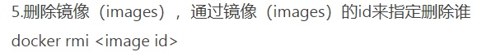

docker rmi repo:tag

删除有依赖关系的镜像的方法

[tag](https://www.runoob.com/docker/docker-tag-command.html)

[build](https://www.runoob.com/docker/docker-build-command.html)

[history](https://www.runoob.com/docker/docker-history-command.html)

[save](https://www.runoob.com/docker/docker-save-command.html)

[load](https://www.runoob.com/docker/docker-load-command.html)

docker load -i xxx.tar

导入镜像到本地

[import](https://www.runoob.com/docker/docker-import-command.html)

**info|version**

[info](https://www.runoob.com/docker/docker-info-command.html)

[version](https://www.runoob.com/docker/docker-version-command.html)